Managed Missions Training Manual FOR TEAM LEADER

Getting started:

https://managedmissions.com
You will be using this site often during the course of your trip preparation, so please bookmark it or add it to your favorites. As you are learning to navigate the site, be sure to watch the online tutorials to learn more about the features of Managed Missions.

If you do not already have a username and password for Managed Missions, you will create one when you complete your application for your trip. After you have completed your application, we will assign you as an administrator (team leader) in Managed Missions for your trip.

Once logged in, this will be your view:

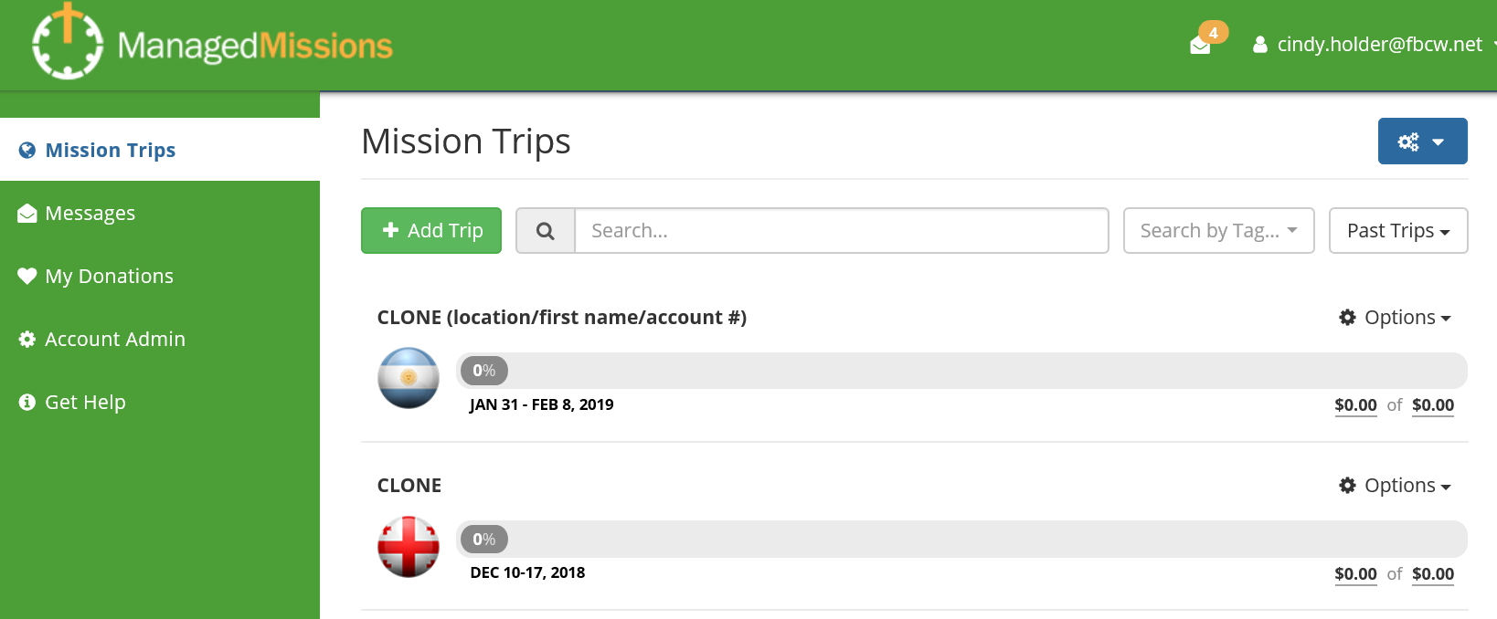

You will see your trip listed. If you are leading more than one trip, you will see multiple trips on this screen.

To view a trip, click on the trip name.

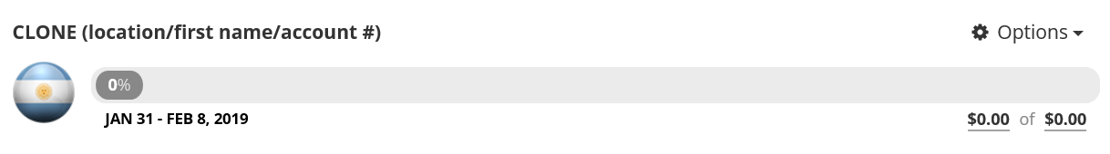

Once you click on your trip, you will see a summary of your trip details.

SEE ATTACHED TRIP DETAILS PAGE

The trip details page will include:
- The trip info (dates, destination, leader)
- Financial summary for the team
- Links – these are links to sites that will be helpful for the team as you prepare to go serve
- Meetings, Tasks and Goals –you can add your meeting dates and notifications will be sent to the team, you can click on the task and it will have an attachment for the form you need, goals are deadlines for various items such as support raising
- Documents – links to all the documents the team will need (including support raising instructions), click on the document to open it

On the trip details page, there will be a left hand tool bar:

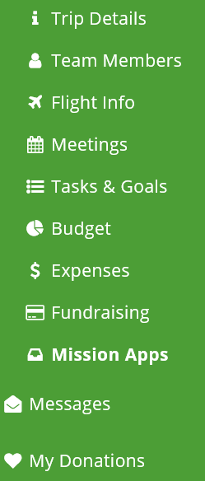

• TEAM MEMBERS
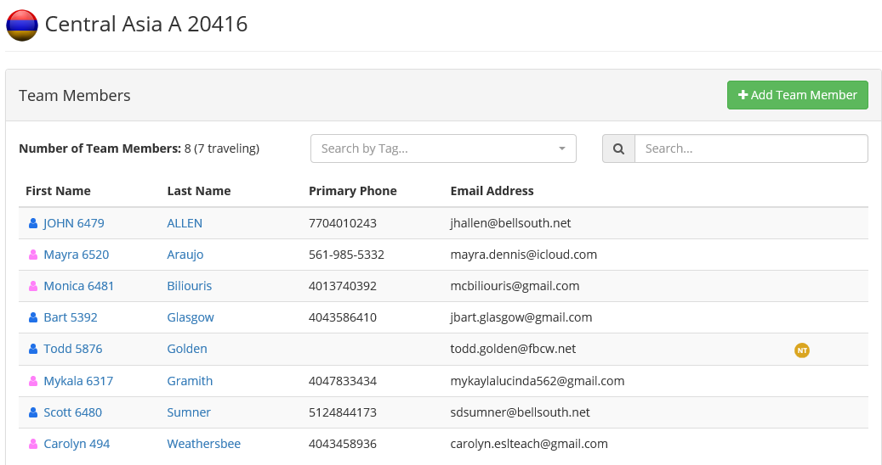

The team member tab lists everyone whose application the administrator (team leader) has approved. The team leader will be able to see every application and all the information. The participant will only be able to see his or her own application. As you hover the browser over a person’s name, you will notice options on the far right for each team member. The envelope icon allows you to email a team member. The pencil allows you to edit personal information. (If a trip participant updates his/her personal information, you will receive an email letting you know). The red circle with an “x” will delete the team member from your team.

- MEETINGS
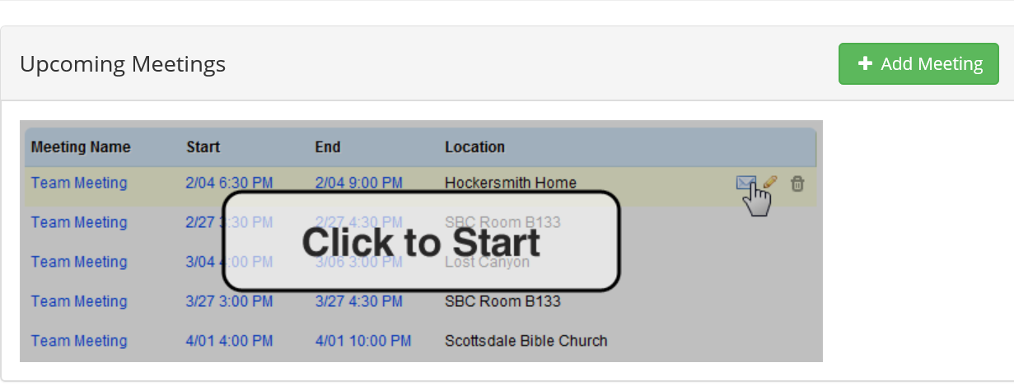

By clicking on the green Add Meeting it allows you to schedule your team meetings and reminder emails will be automatically generated.

- TASKS & GOALS will take you to a page with all the tasks and goals for this trip. Some of these items are leadership tasks and some are member tasks. You also have the option to add new tasks/goals. The page will show you upcoming tasks/goals and past due tasks/goals. Adding a goal refers to a financial option. (The financial goals for your team have already been added. You should see these listed on your Trip Details as well as on the Tasks & Goals tab). Adding a task refers to an action item that the team needs to complete. If you make a task for each item of paperwork due (medical release, covenants, passport copy, deadline for letters, etc), you will have the ability to check people off as they turn in each document. Once a task has been created, you can update it by clicking on the title of the task and adding members who have completed the task.

- BUDGET allows you to input your budget details for the project.

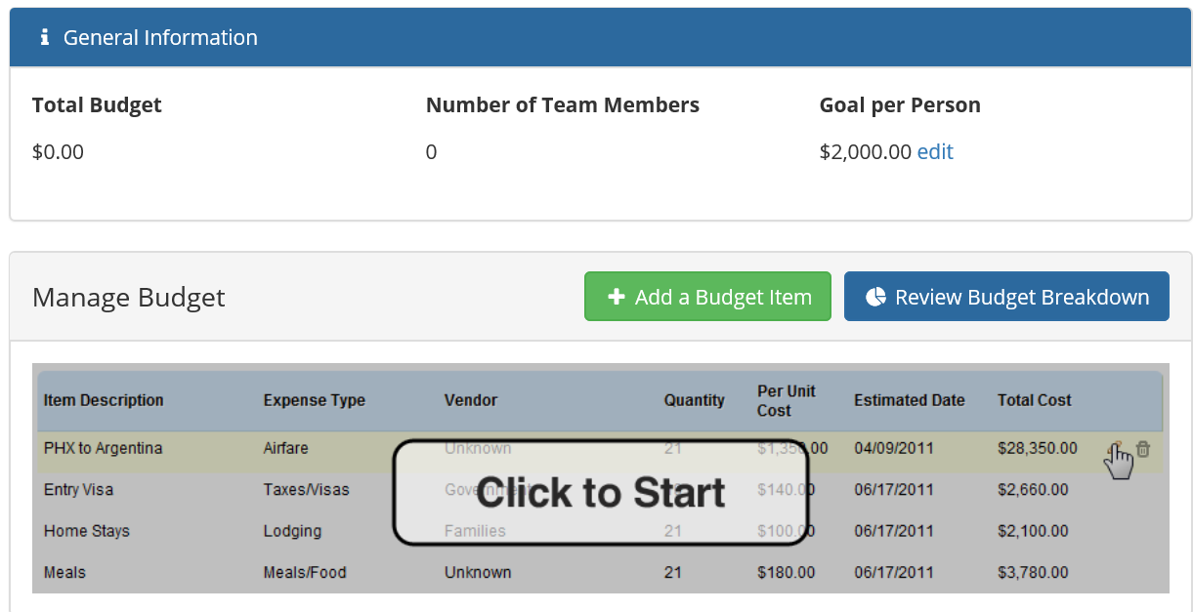

- EXPENSES allows you to track expenditures for the project.

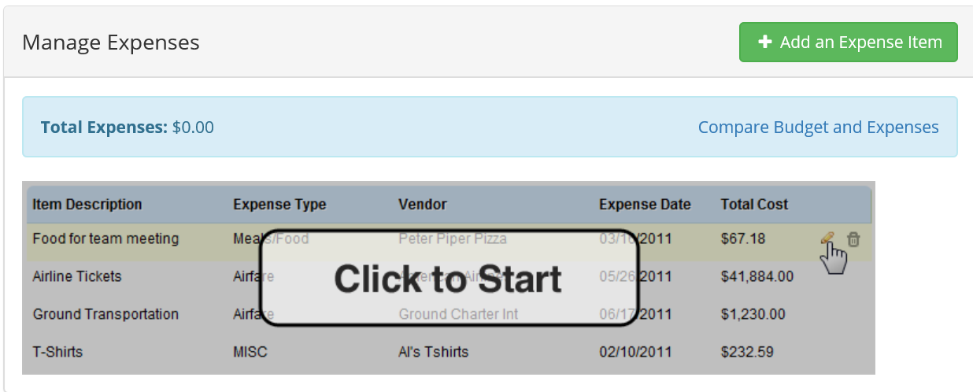

- FUNDRAISING – this is where the team treasurer will manage all the fundraising for the team. When you click on the fundraising tab, it will take you to a contribution summary page which lists all the team members and their individual support raising. As the administrator (team leader), you will see your entire team’s financial summary. When individual trip participants login, they will only see their personal financial summary opposed to the entire team. The team treasurer will be trained in detail on how to enter and track all team support.

- MISSION APPS is where the administrator (team leader) will find applications that are unprocessed and processed. You will need to watch for unprocessed responses.
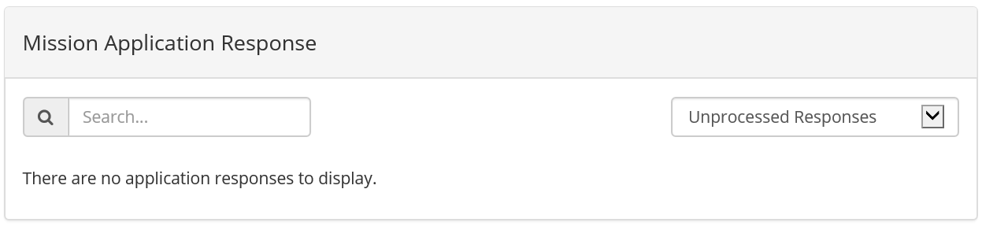

After reading over the applicant’s application, you can select either “Go Back”, “Approve”, or “Don’t Approve”.
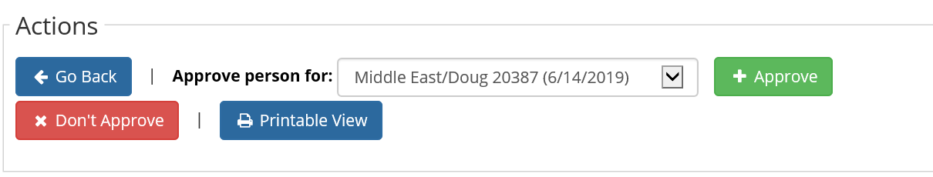

“Go Back” – Takes you back to the Mission Apps main page
“Don’t Approve” – The applicant will not be added to your team
“Approve” – Will add the applicant to your team

You will need to select “Approve” for all applicants you wish to add to your team. Be sure to notify those applicants you have selected, inviting them on your team.

- MESSAGES tab will contain emails from Managed Missions.
- MY DONATIONS will show you all donations you have made to any team.

By clicking on  in the upper right corner of the Team Member page, you will find a dropdown box with the below options:

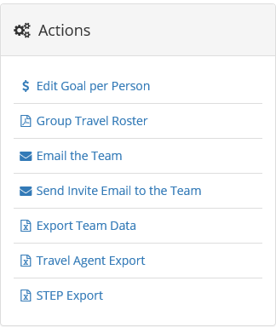

- Edit Goal per Person – if your budget changes and the fund-raising goal needs to be edited, this action will allow changes to be made.

- Group travel roster – You will want to print this and take it with you as it contains pertinent information about each team member. This is NOT the same thing as the Team Travel List.

- Email the team – Communicate with the team as a whole on information relevant to all of them–group retreat, details of next meeting, total fundraising update, etc.

- Send Invite Email to the team – Each individual will create their own username and password when they apply for a trip. This same login information will give them limited access to the site as a trip participant. If needed, you can email your entire team at once with login information using this feature. (*Leaders have more access to personal info).

- Export Team Data, Travel Agent Export and STEP Export – This just exports into an excel sheet the team info from their applications.

